Raising My Hand
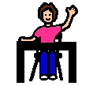

When the teacher is talking to the class, the children are usually quiet.
When someone wants to say something, they usually raise their hand and wait for the teacher to call on them.
When the teacher is talking to the class, I will try to be quiet and listen.
When I want to say something, I will try to remember to raise my hand and wait for the teacher to call on me.
My teacher will be happy if I am quiet.
My teacher will be proud of me if I raise my hand before I talk.

Mo Steinhoff

