Putting My Finger in my Nose

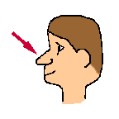

Sometimes I put my finger in my nose. That is not OK. People might have weird thoughts about me when I do this. They might not want to be near me. When I have an itch or I need to clear my nose, I can get a tissue. People will have good thoughts about me when I use a tissue to clear my nose.

Mo Steinhoff

