  I Use Math and Science Smarts at School Too

I use my school smarts to learn many different subjects. That is so cool!

Two subjects I have at school that are very important are math and science.

Sometimes I don’t want to do my math or science. I know I still have to do it. That is OK.

It means I have to use my math and science smarts every day. I can do that!

My teachers work hard, take notes, and prepare materials. They are using their school smarts when they do these things.

I use my school smarts when I do my work, finish my papers, work on math, and do my science. Just like I do in my other classes like LA and social studies.

I can show my teachers how I use my school smarts in all my classes.

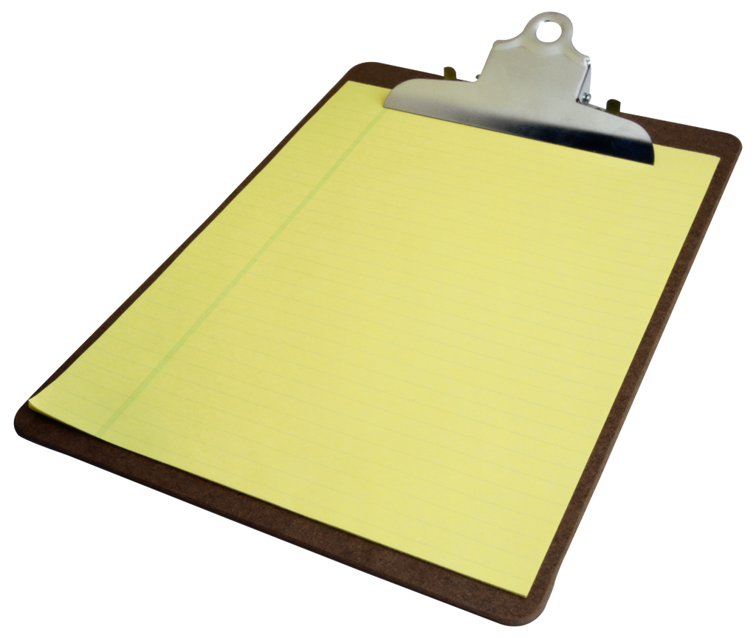science LA 

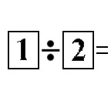math social studies

Mo Steinhoff