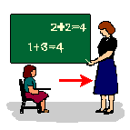
Following my Teachers Directions is the Right Thing to Do

Teachers tell their students what they need to do. This means they care about you.
Following my teacher’s directions in school is very important.
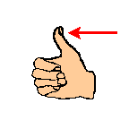
This is good thing.

If my teacher says “Peter, we need to leave the classroom”

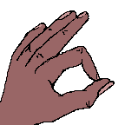
That is OK.

My teacher will tell me when I will come back to class.

Following directions will help me learn and do the right thing.

I can
Look at the teacher

Say OK
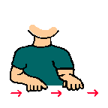
Do what I am told to do.

I will be proud and my teachers will be proud

when I follow directions at school.

Mo Steinhoff

