Following a Schedule

At school I use a schedule to help me remember where my next class is or when I have lunch and surveys. At home I can use a schedule too. My schedule might change but I know it will help me remember what I should be doing. A schedule can also help me know how much time I can spend on each activity. For example when I go to art I am there for one hour. At home I might spend 15 minutes in my room and then go downstairs for 15 minutes. Sometimes I will spend longer than 15minutes down stairs. I know that is OK! My mom and dad will help me remember my schedule so that I will know when I should be upstairs or downstairs or even outside to play. Having a schedule will help me at home just like it helps me at school.

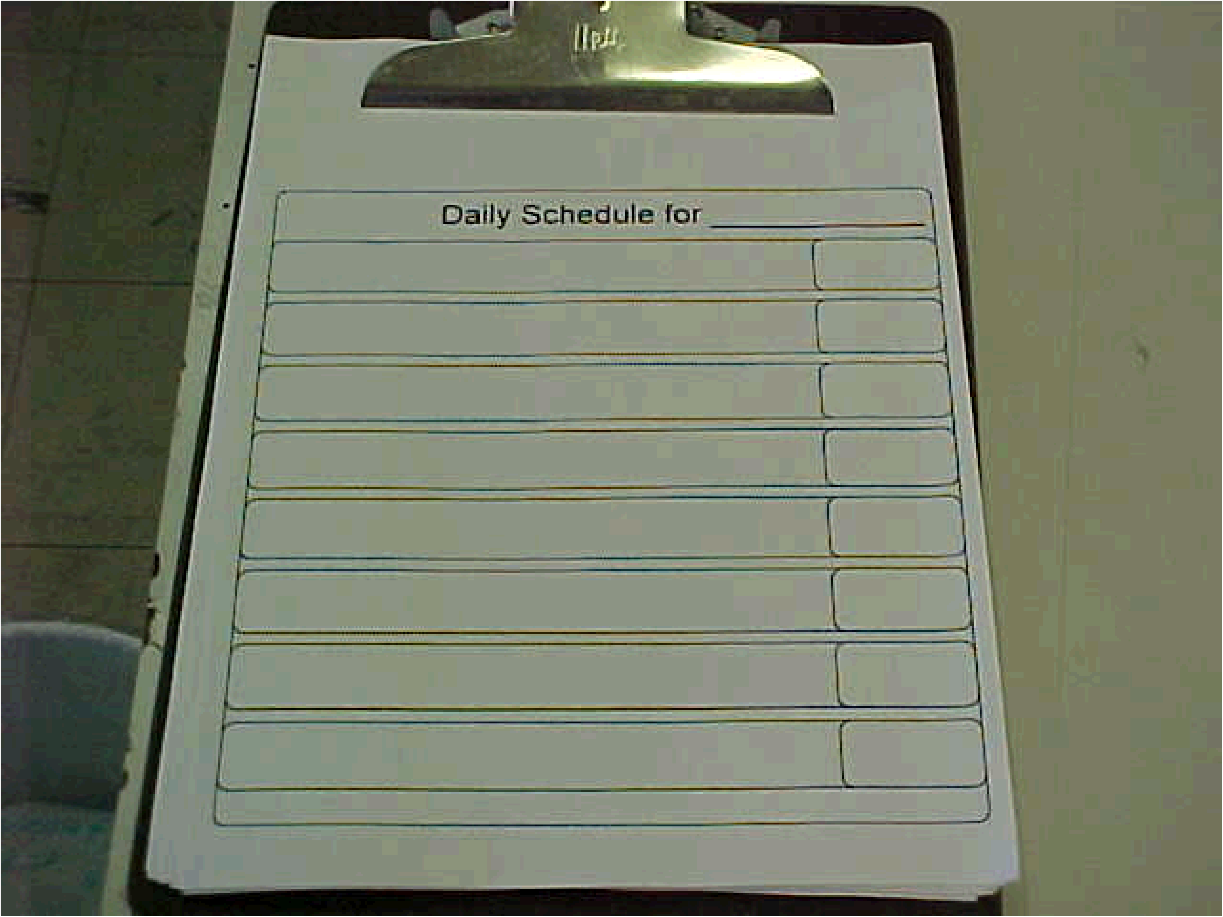
______________’s daily schedule for Home

Mo Steinhoff

