**Some Things are for Home and Some are for School**

I have many things at home that I like very much. Sometimes I wish I could bring them to school. I know that I need to leave my special things at home. That is OK. When I go home I can make time to play with or use my special things. I can bring a snack or my books from home and that is all I really need. I know my teachers will be so proud of me when I bring only the things I need for school from home. I will be proud too!

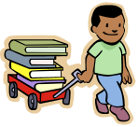 Books are for school 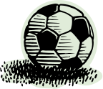

Toys are for home

Mo Steinhoff